**Lab 6- MAC/ARP**

**IT 520-A Enterprise Infrastructure & Networks**

1. My IP Address Screenshot

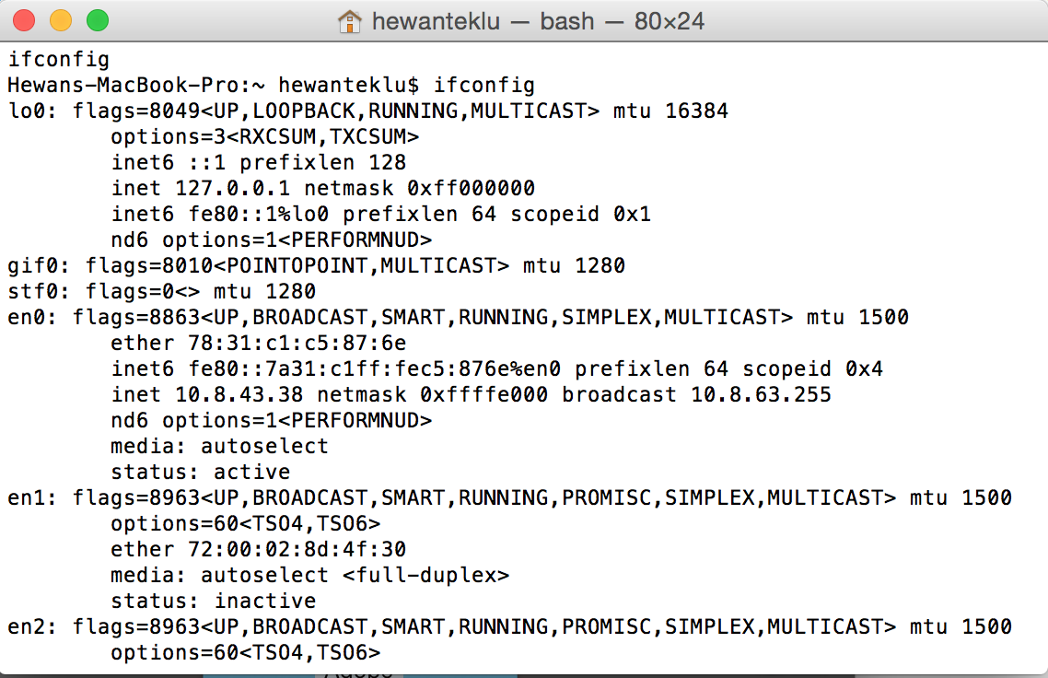

**Solution:**

**10.8.43.38**

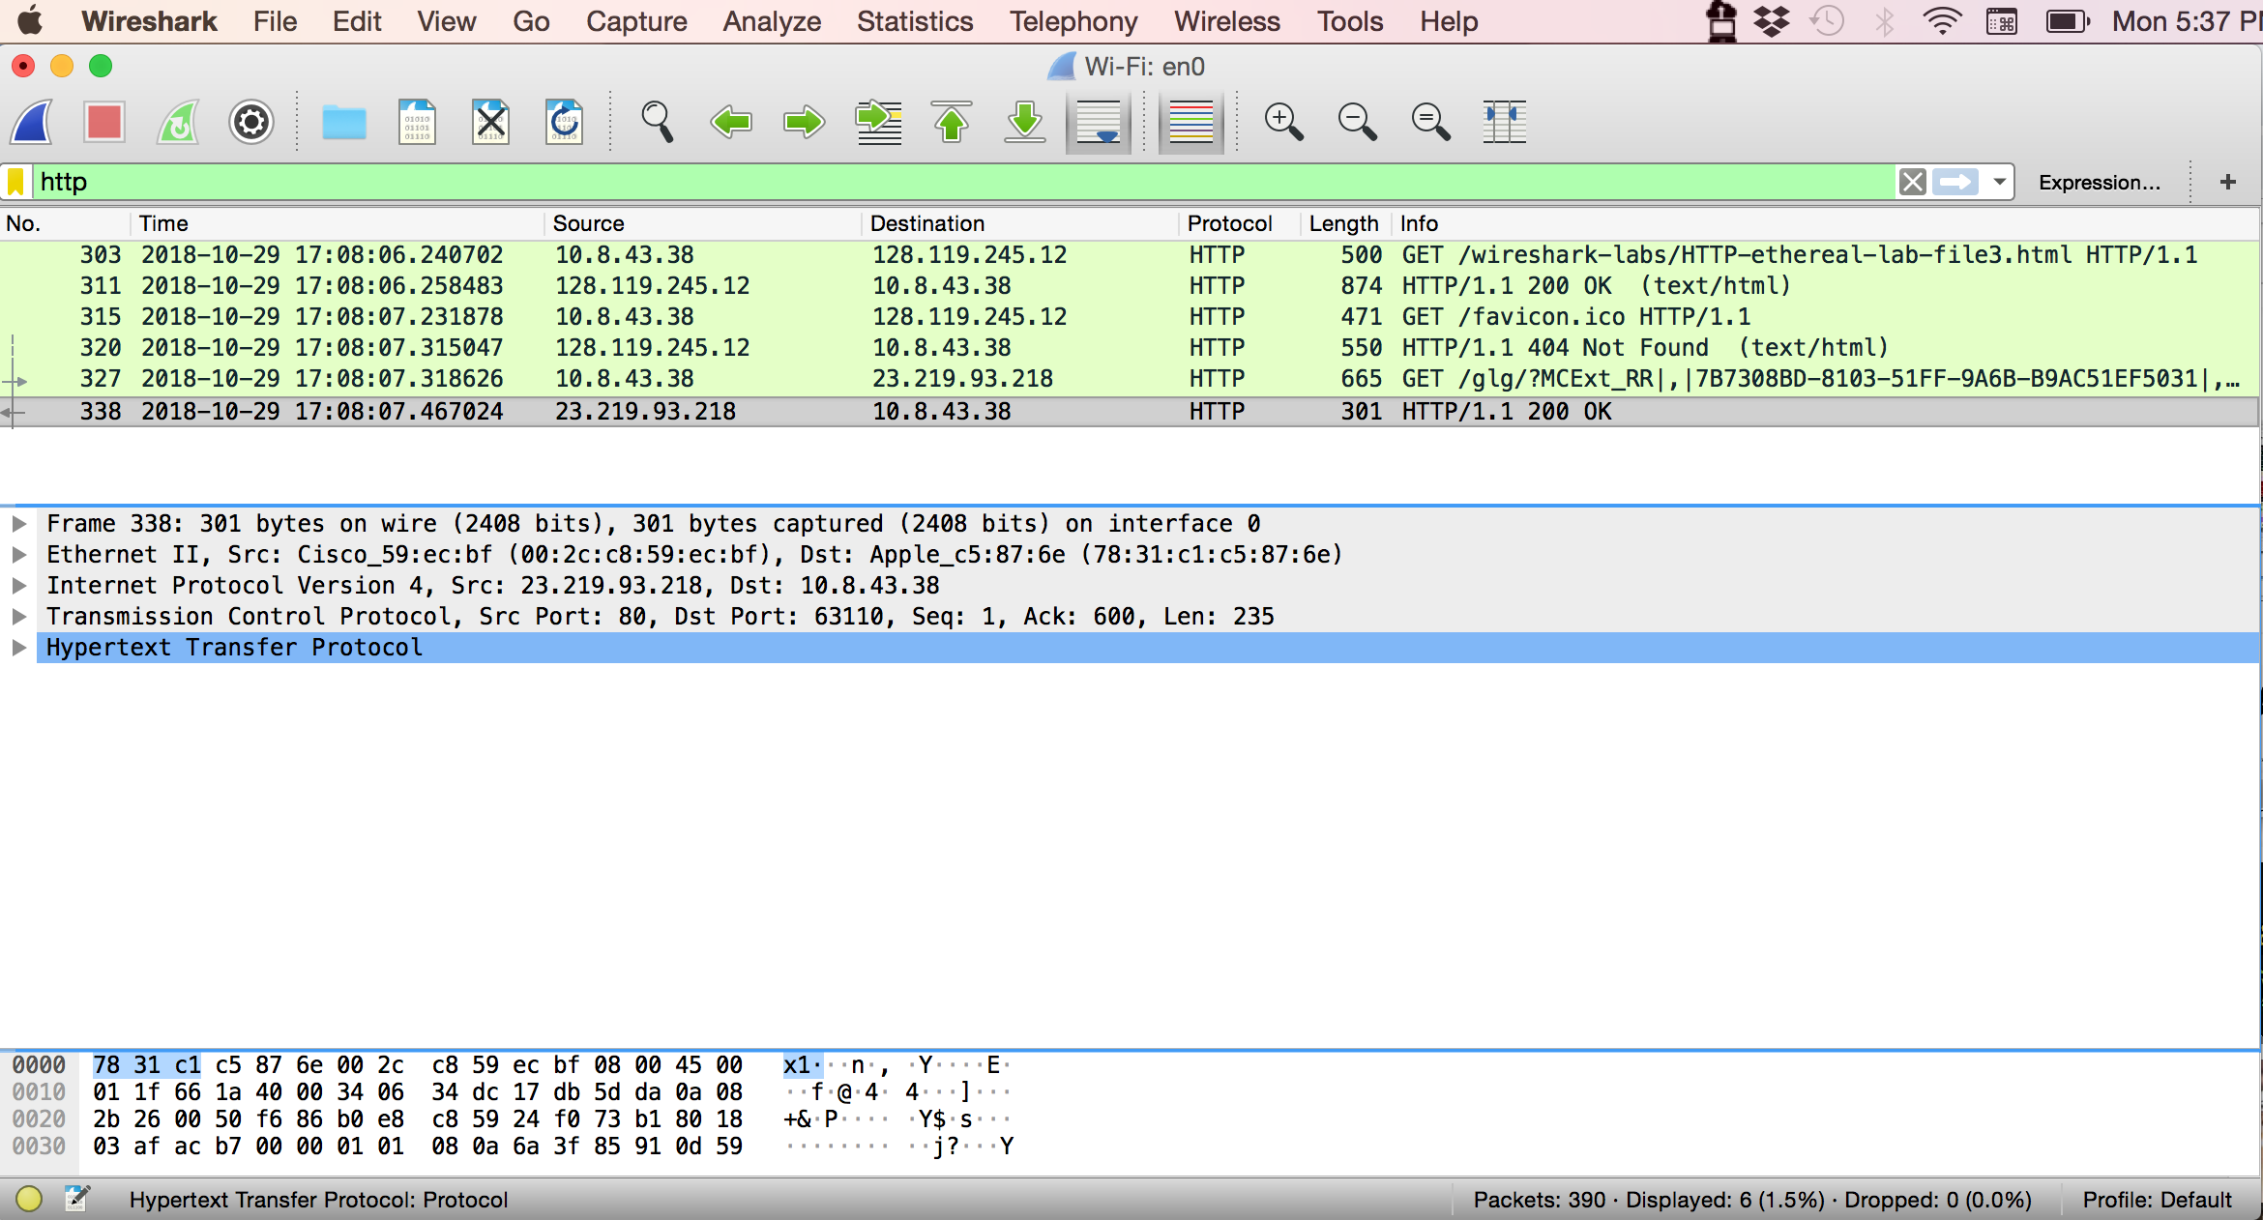

1. What is the MAC address from your computer?

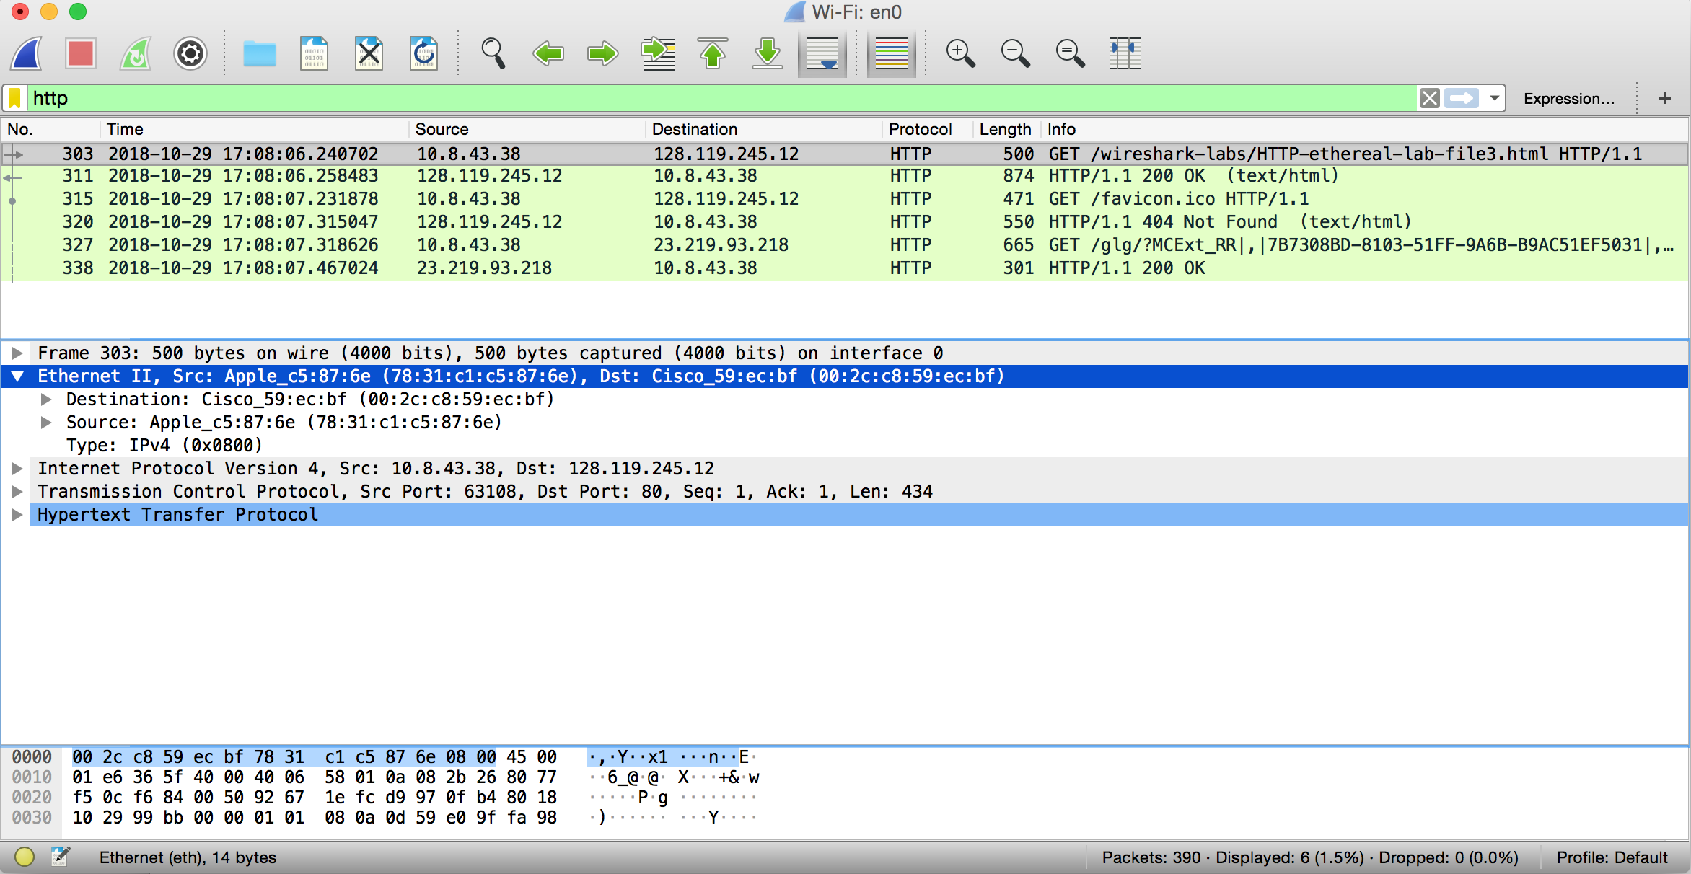

**Solution:**

**78:31:c1:c5:87:6e**

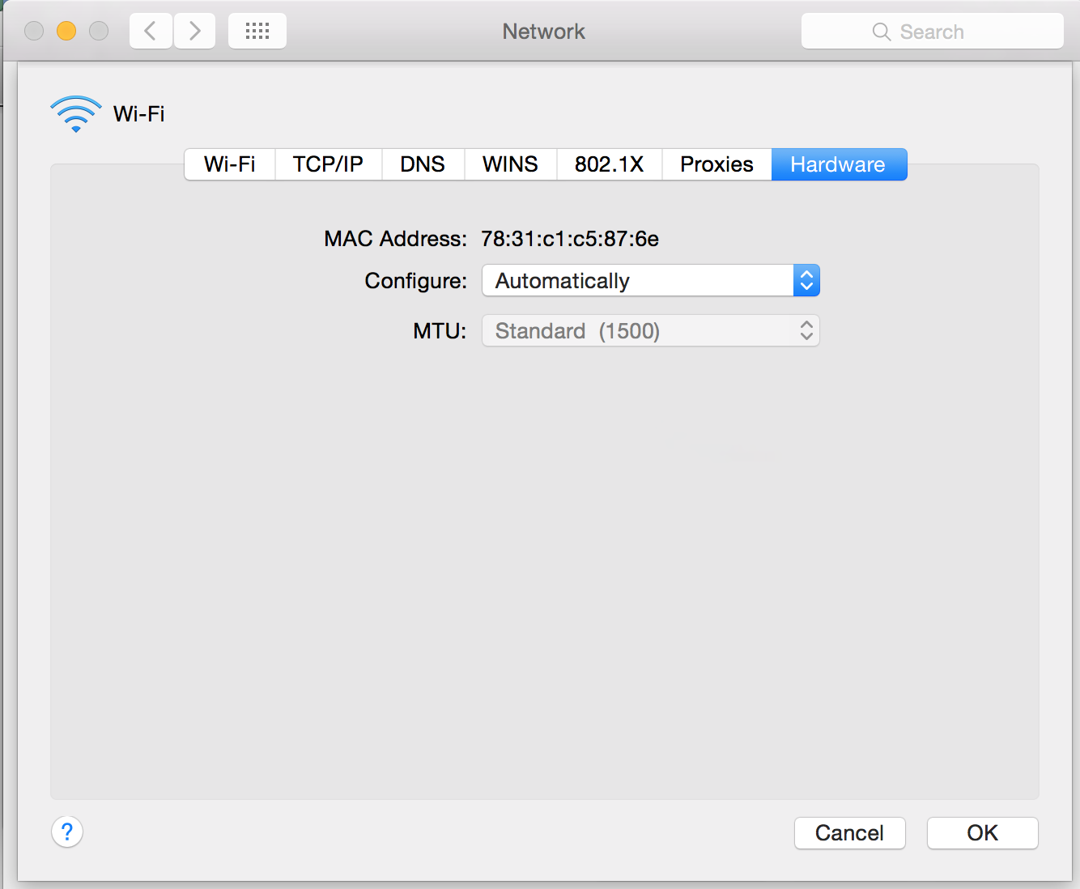

1. What is the destination MAC address?



**Solution:**

**00:2c:c8:59:ec:bf**

1. What device has the MAC address shown in the destination?



**Solution:**

**Cisco_59:ec:bf**

1. Explain the relationship between the destination MAC address and the destination IP address.

**Solution:**

The ARP cache is the link between the destination MAC address and the destination IP address. The Address Resolution Protocol(ARP) is responsible for converting an IP-address to a MAC-address. ARP associates MAC addresses with IP addresses and is a way for a computer to look up an unknown MAC address for a device that it wants to communicate with. ARP lets devices on the network ask each other which MAC addresses they have.

1. Using the terminal (cmd in Windows, Terminal in mac), run a command to display your full ARP list table. (Find out what the command is, and print a full screen shot of your result.)

